UNIT 6
Web Application life cycle model

6.1 Introduction to life cycle model
Web development is all the rage today. It has become essential for businesses to have a high-functioning website or web application to cater to the digital requirements of customers. Almost all companies, no matter the field of operation, are focusing on creating a well-designed site for marketing their services. But the web development process does not only involve coding. With a hundred aspects that need to be taken into consideration, it becomes imperative to follow a structured process to avoid problems.
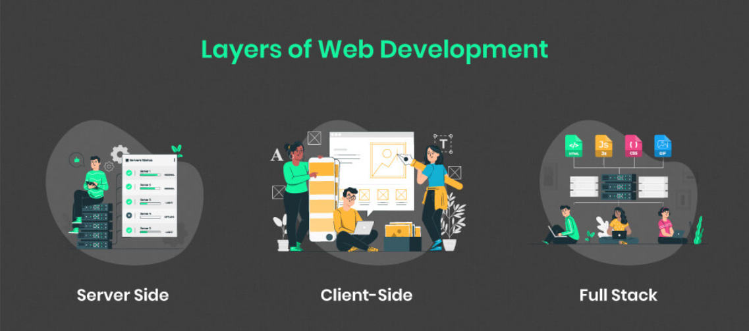
A web development life cycle concerns all the stages that go into building the website, from formulating the idea to coding and designing to deploying and maintaining. It is the standard or methodical step to follow to achieve a well-functioning website. It gives a basic outline for a web developer and project manager to follow to ensure minimum errors and optimal results.
The 7 stages of web development cycle are –
- Research
- Planning
- Designing
- Content creation
- Development
- Testing
- Deployment & Maintenance.
Research & Analysis
Most people ignore this critical step in the web development process. To ensure that your design and development is on the right path, gathering information about the project and the client is crucial. Unless your developers have a clear idea of what they are working for and what the requirements are, they will not be able to provide the right solution. During this phase, it is important to visualize what type of people your website is going to be catering to. Taking into consideration their age, gender, preferences, and needs, set goals and generate requirement elicitation documents. Many times, conducting surveys and getting user’s feedback on what problems they are facing and what solutions they are looking for proves beneficial.
Planning
Based on the information gathered and analyzed in the last stage, informed decisions are made about the structure and features of the website. It involves strategizing all the aspects of the website including design, technology, content, and marketing. Deciding on the content structure, wireframe (schematics and rough designs), choosing the technology stack and software development methodology are important decisions to take before website creation. All of this information should be documented in an organized fashion in a place that is easily accessible by all members of the project. There are many great tools for this online, but a personal favorite of mine is Trello.
Designing
The web design stage involves designing website layout and brings in the creative UI-UX designers to the forefront. The layout involves designing a rough sketch, which may be graphical, to get a feel of the design of the website. The purpose of the layout is to present an information structure, enabling a visual tour of the content and base features for your clients.
The wireframe designed in the last stage is transformed into buttons, tabs, menus, dashboards, color themes, typography, and graphics to create a base layout of the website.
Content
Eventually, content is king. If you are unable to communicate with your customers and readers, no amount of fancy design can help you. Creating a communication channel through the user interface is the main aim of the content creation stage. Content writing involves providing relevant information about your company in an easy-to-understand, attractive manner. Adding calls-to-action, creative headlines, formatting, line editing, writing, and updating texts go on throughout the web development lifecycle.
Code and Development
Developing the client-side and server-side of the website is accomplished in this stage. It is the most time-consuming part of the website development process.
Frontend development
Backend development

Testing & Quality Assurance
After the website is developed, a set of rigorous tests are conducted to eliminate any bugs in the system. The QA team performs repeated testing methods such as Unit testing, Stress testing, and Load testing meticulously, checking the functionality, usability, compatibility, and performance of the web app.
Deployment & Maintenance
Once you receive the stamp of approval from the QA team, the website or app is finally ready for deployment. Using File Transfer Protocol, the app is hosted on the web servers and is available to the viewers. But the work is not over. Continuous feedback from user interaction lets you know the scopes of improvement. Accordingly, the web application development life cycle is executed to make the necessary modifications.
Apart from this, regular maintenance and updates are absolutely crucial to keep the site functioning perfectly and engage new users.

6.2 Life cycle models
There are various software development life cycle models defined and designed which are followed during the software development process. These models are also referred as Software Development Process Models". Each process model follows a Series of steps unique to its type to ensure success in the process of software development.
Following are the most important and popular SDLC models followed in the industry −
- Waterfall Model
- Iterative Model
- Spiral Model
- V-Model
- Big Bang Model
Waterfall Model:
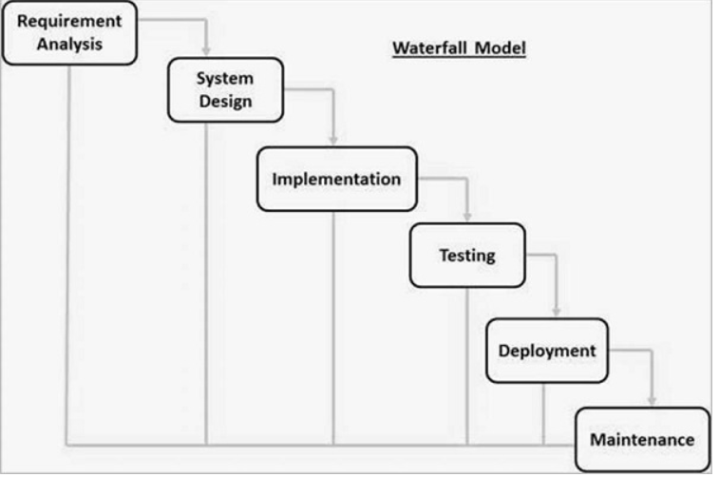
Iterative model:
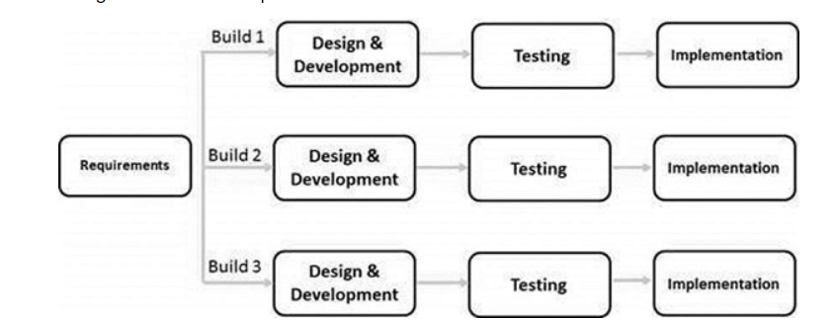
Spiral Model:
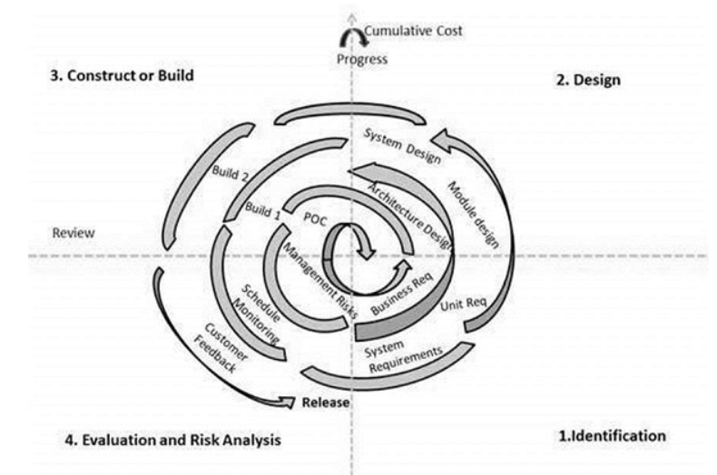
Some of the life cycle models are discussed below:

6.2.1 Extreme Programming

What is Agile?
The word ‘agile’ means −
- Able to move your body quickly and easily.
- Able to think quickly and clearly.
In business, ‘agile’ is used for describing ways of planning and doing work wherein it is understood that making changes as needed is an important part of the job. Business ‘agililty’ means that a company is always in a position to take account of the market changes.
Extreme programming (XP) is one of the most important software development framework of Agile models. It is used to improve software quality and responsive to customer requirements. The extreme programming model recommends taking the best practices that have worked well in the past in program development projects to extreme levels.
Extreme Programming is based on the following values −
- Communication
- Simplicity
- Feedback
- Courage
- Respect
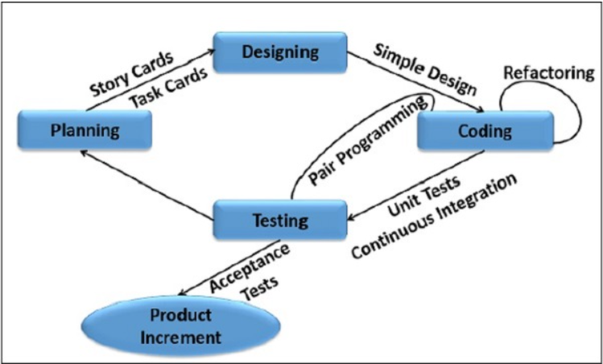
Some of the basic activities that are followed during software development by using XP model are given below:
Coding: The concept of coding which is used in XP model is slightly different from traditional coding. Here, coding activity includes drawing diagrams (modeling) that will be transformed into code, scripting a web-based system and choosing among several alternative solutions.
Testing: XP model gives high importance on testing and considers it be the primary factor to develop a fault-free software.
Listening: The developers needs to carefully listen to the customers if they have to develop a good quality software. Sometimes programmers may not have the depth knowledge of the system to be developed. So, it is desirable for the programmers to understand properly the functionality of the system and they have to listen to the customers.
Designing: Without a proper design, a system implementation becomes too complex and very difficult to understand the solution, thus it makes maintenance expensive. A good design results elimination of complex dependencies within a system. So, effective use of suitable design is emphasized.
Feedback: One of the most important aspects of the XP model is to gain feedback to understand the exact customer needs. Frequent contact with the customer makes the development effective.
Simplicity: The main principle of the XP model is to develop a simple system that will work efficiently in present time, rather than trying to build something that would take time and it may never be used. It focuses on some specific features that are immediately needed, rather than engaging time and effort on speculations of future requirements.

6.2.2 Scrum
Scrum is an agile development methodology used in the development of Software based on an iterative and incremental processes. Scrum is adaptable, fast, flexible and effective agile framework that is designed to deliver value to the customer throughout the development of the project. The primary objective of Scrum is to satisfy the customer’s need through an environment of transparency in communication, collective responsibility and continuous progress. The development starts from a general idea of ​​what needs to be built, elaborating a list of characteristics ordered by priority (product backlog) that the owner of the product wants to obtain.
Scrum is executed in temporary blocks that are short and periodic, called Sprints, which usually range from 2 to 4 weeks, which is the term for feedback and reflection. Each Sprint is an entity in itself, that is, it provides a complete result, a variation of the final product that must be able to be delivered to the client with the least possible effort when requested.
Sprint
A sprint in Scrum is a short period of time wherein a development team works to complete specific tasks, milestones, or deliverables. Sprints, also referred to as “iterations,” essentially break the project schedule into digestible blocks of time in which smaller goals can be accomplished.

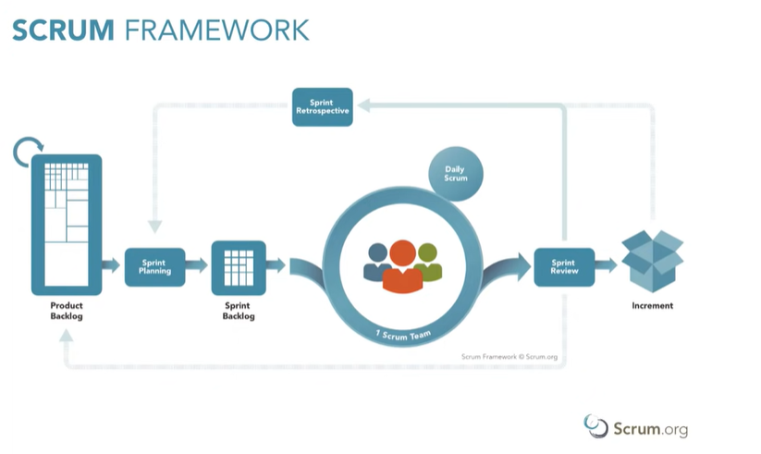
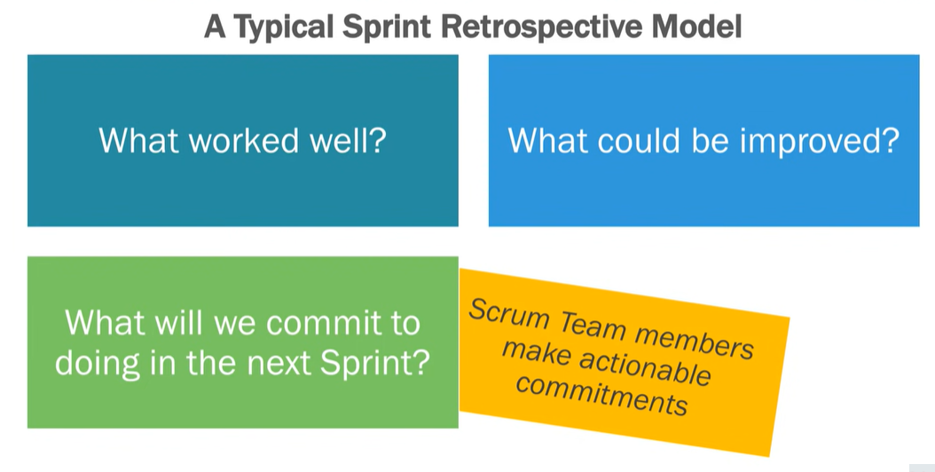
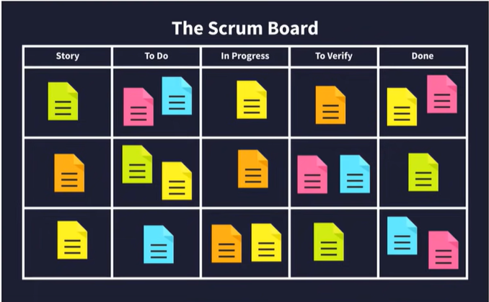

6.2.3 Time Boxing
In time boxing model, development is done iteratively as in the iterative enhancement model. However, in time boxing model, each iteration is done in a timebox of fixed duration. The functionality to be developed is adjusted to fit the duration of the timebox. Moreover, each timebox is divided into a sequence of fixed stages where each stage performs a clearly defined task (analysis, implementation, and deploy) that can be done independently.
There is a dedicated team for each stage so that the work can be done in pipelining. Thus, stages should be chosen in such a way that each stage perform some logical unit of work that becomes the input for next stage.
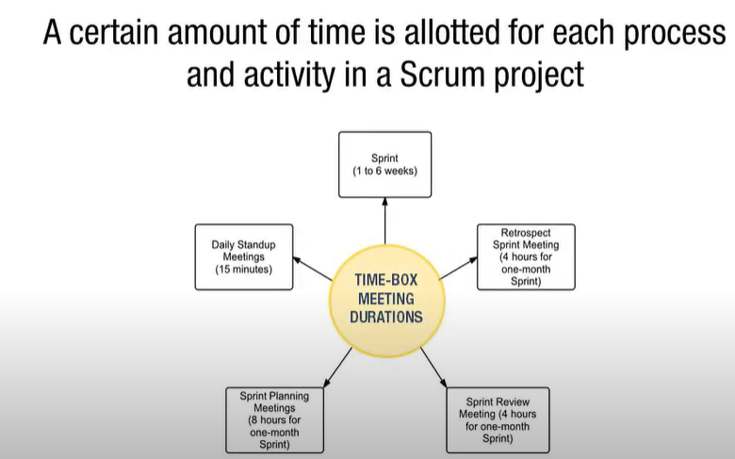

6.2.4 Feature-Driven Development
FDD stands for Feature-Driven Development. It is an agile iterative and incremental model that focuses on progressing the features of the developing software. The main motive of feature-driven development is to provide timely updated and working software to the client. In FDD, reporting and progress tracking is necessary at all levels.
Characteristics of FDD
Short iterative: FDD lifecycle works in simple and short iterations to efficiently finish the work on time and gives good pace for large projects.
Customer focused: This agile practice is totally based on inspection of each feature by client and then pushed to main build code.
Structured and feature focused: Initial activities in lifecycle builds the domain model and features list in the beginning of timeline and more than 70% of efforts are given to last 2 activities.
Frequent releases: Feature-driven development provides continuous releases of features in the software and retaining continuous success of the project.
Advantages of FDD
- Reporting at all levels leads to easier progress tracking.
- FDD provides continuous success for larger size of teams and projects.
- Reduction in risks is observed as whole model and design is built in smaller segments.
- FDD provides greater accuracy in cost estimation of the project due to feature segmentation.
Disadvantages of FDD
- This agile practice is not good for smaller projects.
- There is high dependency on lead programmers, designers and mentors.
- There is lack of documentation which can create an issue afterwards.
